Ideation Phase
Brainstorm & Idea Prioritization Template

Date | 25 June 2026
Team ID
Project Name | SB Stocks – Paper Trading Platform
Maximum Marks | 4 Marks
Step-1: Team Gathering, Collaboration and Select the Problem Statement

Problem Identified
Many students and beginner investors want to learn stock market trading but are hesitant to invest real money due to financial risk and lack of practical experience.Existing trading platforms are often designed for experienced investors and are not beginner-friendly. Therefore, there is a need for a simple and secure paper trading platform that allows users to practice stock trading using virtual money.
Selected Problem Statement
"Develop a secure web-based paper trading platform that enables users to simulate stock market trading using virtual funds, helping beginners gain practical experience without financial risk."
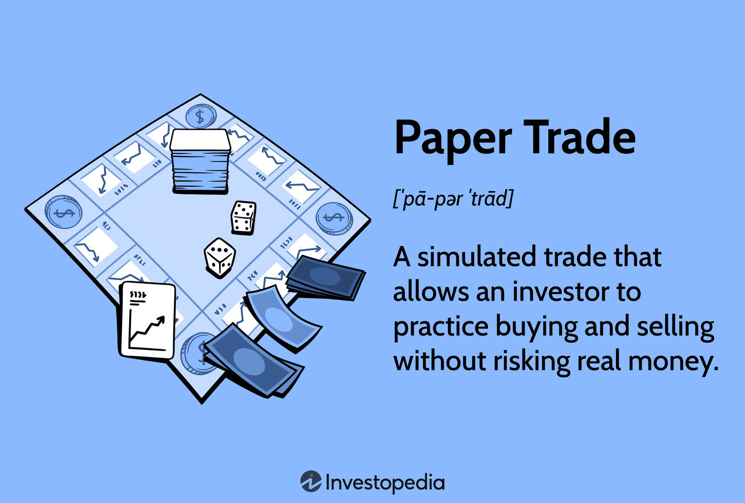

Step-2: Brainstorm, Idea Listing and Grouping

Brainstormed Ideas
S.No | Idea | Category
1 | Paper Trading Platform | Finance
2 | Student Attendance Management System | Education
3 | Online Library Management System | Education
4 | Personal Expense Tracker | Finance
5 | Online Food Ordering System | E-Commerce
6 | Hospital Appointment System | Healthcare
7 | AI Resume Builder | Career
8 | Weather Forecast Application | Utility

Idea Grouping

Finance
- Paper Trading Platform
- Expense Tracker

Education
- Student Attendance System
- Library Management System

Healthcare
- Hospital Appointment System

E-Commerce
- Food Ordering System

Career
- AI Resume Builder

Utility
- Weather Forecast Application

Step-3: Idea Prioritization
Idea | Innovation | Technical Feasibility | Social Impact | Learning Opportunity | Overall Priority
SB Stocks – Paper Trading Platform | ⭐⭐⭐⭐⭐ | ⭐⭐⭐⭐⭐ | ⭐⭐⭐⭐⭐ | ⭐⭐⭐⭐⭐ | 1
Expense Tracker | ⭐⭐⭐ | ⭐⭐⭐⭐⭐ | ⭐⭐⭐ | ⭐⭐⭐ | 2
Student Attendance System | ⭐⭐⭐ | ⭐⭐⭐⭐ | ⭐⭐⭐⭐ | ⭐⭐⭐ | 3
Library Management System | ⭐⭐⭐ | ⭐⭐⭐⭐ | ⭐⭐⭐ | ⭐⭐⭐ | 4
Hospital Appointment System | ⭐⭐⭐⭐ | ⭐⭐⭐ | ⭐⭐⭐⭐ | ⭐⭐⭐ | 5
Food Ordering System | ⭐⭐⭐ | ⭐⭐⭐ | ⭐⭐⭐ | ⭐⭐⭐ | 6
AI Resume Builder | ⭐⭐⭐⭐ | ⭐⭐⭐ | ⭐⭐⭐⭐ | ⭐⭐⭐⭐ | 7
Weather Forecast Application | ⭐⭐ | ⭐⭐⭐⭐ | ⭐⭐ | ⭐⭐ | 8

Final Selected Idea

SB Stocks – Paper Trading Platform

Reason for Selection
- Solves a real-world problem for beginners.
- Enables stock market learning without financial risk.
- Uses modern MERN Stack technologies.
- Demonstrates full-stack web development skills.
- Includes secure JWT authentication.
- Provides portfolio and transaction management.
- Suitable for educational and internship purposes.
- Easily scalable with future enhancements such as live stock APIs and AI-based recommendations.

Expected Outcome
The proposed solution will provide users with a secure and responsive web application where they can:
- Register and log in securely.
- View available stocks.
- Buy and sell stocks using virtual money.
- Manage their investment portfolio.
- Track transaction history.
- Gain confidence and practical knowledge before entering real stock markets.

